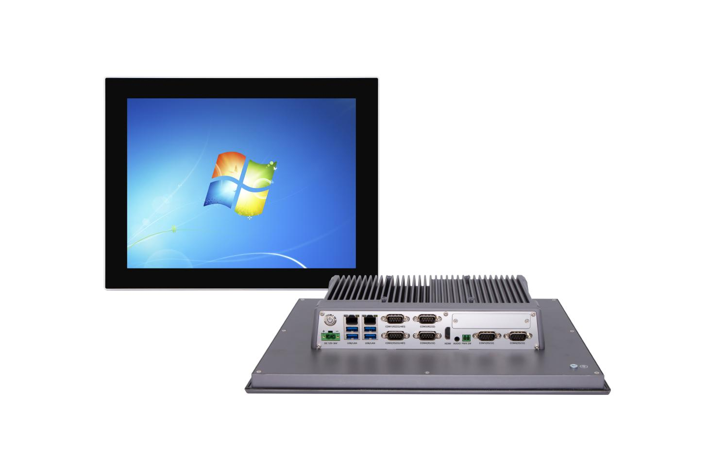

**Industrial Panel PC**

**QY-P8150**

**Products Features:**

1. **Industrial-Grade Embedded Fanless Panel PC**
2. **15 inch LED Screen, Resolution: 1024*768**
3. **Support Capacitive and Resistive Touch Screen**
4. **Intel Celeron / Atom / Core 4/7/8/10/12/13th-i3/i5/i7 CPU**
5. **2*RJ-45, 4*USB, 6*COM, 1*HDMI**
6. **1*Expansion Slot, Support 4G/5G and WIFI module**
7. **DC 9-36V Power Input With Overvoltage Protection**
8. **-20℃~50℃ Temperature Can Keep 24/7 Work Stably**
9. **1*Multifunctional Daughter card slot**
10. **Anti-Static, Anti-Pulse, Anti-Surge, Anti-Radiation**

**QY-P8150**

**1.Mother Board Specification:**

|  |  |  |  |
| --- | --- | --- | --- |
| **Model** | **QY-P8150** | | |
| **CPU** | **J1900**  **i3-4010U**  **i5-4260U**  **i7-4650U** | **J6412**  **i3-7100U / 8130U / 10110U**  **i5-7200U / 8250U / 10310U**  **i7-7500U / 8550U / 10710U** | **N95 / N100**  **i3-1215U / 1315U**  **i5-1235U / 1335U**  **i7-1255U / 1270P / 1355U** |
| **Memory[1]** | **2*DDR III RAM Slots,Up to 16GB** | **2*DDR IIII RAM Slots, Up to 32GB** | **2*DDR IIII RAM Slots, Up to 64GB** |
| **Storage** | **1*MSATA SSD Slot**  **1*SATA SSD Slot** | | **1*M.2 NVME SSD Slot** |
| **Display[2]** | **1*HDMI: Resolution up to 4096*2106@60Hz** | | |
| **Expansion** | **1*Mini PCIE Slot** | | **2*M.2 Slots** |
| **Support 4G/5G and WIFI Module** | | |
| **Ethernet** | **2*Intel LAN Chip (10 / 100 / 1000 Mbps, RJ-45 Type)** | | |
| **USB** | **4*USB 3.0 (Type-A)**  **1*USB 2.0 (Type-A, Built-in)** | | |
| **COM** | **2*RS-232 / 422 / 485 (DB9 type)**  **4*RS-232 (DB9 type)** | | |
| **Audio** | **1*Line-Out** | | |
| **Daughter Card** | **Support expansion more I/O interfaces and functional slots** | | |

**Notes:**

**[1]: The maximum memory capacity and the maximum capacity per strip supported by this motherboard depend on the CPU.**

**[2]: The maximum resolution and frame rate of the display interface output depends on the CPU.**

**2.Screen Specification:**

**QY-P8150**

|  |  |  |
| --- | --- | --- |
| **Screen Size** | **15 inch TFT LED Screen, 4:3 Size** | |
| **Resolution** | **1024*768** | |
| **Brightness** | **350nits** | |
| **Largest Colorful** | **16M** | |
| **Touch Screen Type** | **Capacitive** | **Resistive** |
| **Transmittance** | **More than 95%** | **More than 95%** |
| **Touch Life** | **50 million times** | **35 million time** |
| **Response Time** | **＜5ms** | **＜5ms** |
| **Touch Hardness** | **7 Mohs** | |
| **Protection** | **Front Panel IP65 Water Proof** | |

**QY-P8150**

**3.Device Specification:**

|  |  |
| --- | --- |
| **Power Input** | **DC 9-36V with over-voltage protection** |
| **Support auto-start** |
| **2 Pin Phoenix Terminal type DC Plug** |
| **Structure** | **Fully Enclosed Aluminum Alloy Material** |
| **Heat Dissipation** | **Fanless Design, Conduction Heat Dissipation** |
| **Installation** | **Desktop / Embedded / Wall Mount** |
| **Size** | **370mm*290mm*68mm** |
| **System** | **Windows and Linux** |

**QY-P8150**

**4.Optional Specification:**

|  |  |  |
| --- | --- | --- |
| **Screen** | **Brightness** | **Optional 1000 nits LED screen** |
| **Optional brightness auto adjustment function** |
| **Anti-Glare** | **Optional** |
| **Camera** | **Optional 200w or 500w camera (Built-in front panel)** |
| **Full Lamination** | **Optional** |

**QY-P8150**

**5.Daughter Card Specification:**

|  |  |
| --- | --- |
| **COM Port-2** | **2*RS-232 / 485 (DB9 type)** |
| **COM Port-6** | **4*RS-232 / 485+2*RS-232 (Phoenix terminal type)** |
| **Ethernet Port-2** | **2*Intel i211V LAN Chip (RJ-45 type)** |
| **Ethernet Port-4** | **4*Intel i211V LAN Chip (RJ-45 type,POE function optional)** |
| **10G Ethernet Port-2** | **2*10Gbps Ethernet Ports** |
| **USB Port-4** | **4*USB 3.0 (Type-A)** |
| **GPIO Port-14** | **14 ports GPIO, 7*GPI+7*GPO, 0-3.3V (Phoenix terminal type)** |
| **DIDO Port-16** | **16 ports DIDO, 8*DI+8*DO, 24V, Isolation (Phoenix terminal type)**  **Comes with 4*RS-485 COM ports (Phoenix terminal type)** |
| **Mini PCIE Slot-2** | **2*Mini PCIE slots, Support 4G and WIFI module** |
| **M.2 Slot-1** | **1*M.2 Key-B slot, Support 5G module** |
| **M.2 NVME SSD Slot-1** | **1*M.2 NVME SSD slot** |
| **SATA SSD Slot-1** | **1*SATA 3.0 SSD Slot, Support RAID 1** |
| **CAN Port-2** | **2*CAN interfaces (Phoenix terminal type)** |
| **UPS battery** | **1.2AH or 4.8AH** |

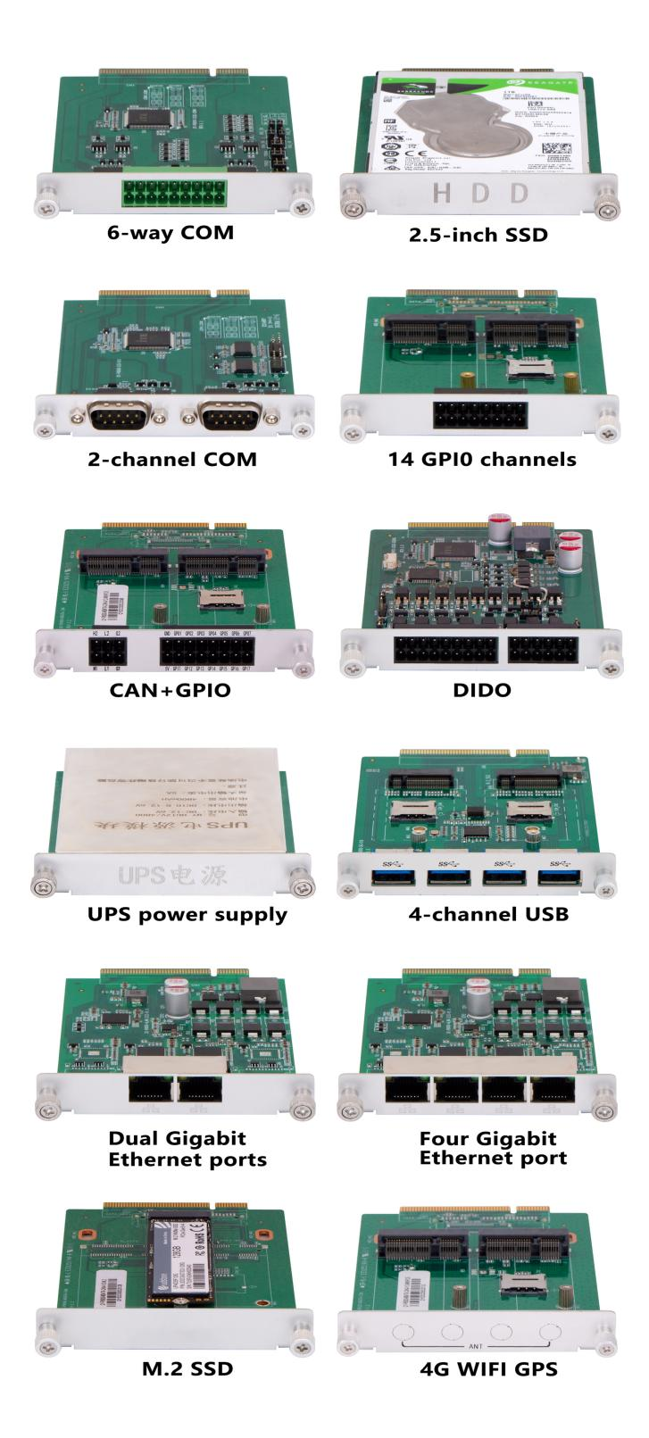

**QY-P8150**

**6.Ordering Information:**

|  |  |  |  |  |  |  |  |  |  |
| --- | --- | --- | --- | --- | --- | --- | --- | --- | --- |
| **Model** | **CPU** | **LAN** | **USB** | **COM** | **RAM** | **Display** | **SSD** | **Expansion** | **Power** |
| **QY-P8150** | **J1900** | **2** | **4** | **2*RS-232/422/485**  **4*RS-232** | **1*DDR 3**  **Up to 8GB** | **1*HDMI** | **1*MSATA**  **1*SATA** | **1*Mini PCIE** | **DC 9-36V** |
| **4th** | **2*DDR 3**  **Up to 16GB** |
| **J6412** | **2*DDR 4**  **Up to 32GB** |
| **7th** | **2*DDR 4**  **Up to 32GB** |
| **8th / 10th** | **2*DDR 4**  **Up to 64GB** |
| **N95 / N100** | **1*DDR 4**  **Up to 16GB** | **1*M.2 NVME** | **1*M.2**  **1*Mini PCIE** |
| **12th / 13th** | **2*DDR 4**  **Up to 64GB** | **2*M.2** |

**QY-P8150**

**7.CPU Information:**

|  |  |  |
| --- | --- | --- |
| **CPU** | **Specification** | |
| **J1900** | **4 core, 4 total threads, 2.00 GHz to 2.42GHz, 2 MB cache** | **Max to 8GB for 1*DDR 3 Slot** |
| **i3-4010U** | **2 core, 4 total threads, 1.70 GHz, 3 MB Cache** | **Max to 16GB for 2*DDR 3 Slots** |
| **i5-4260U** | **2 core, 4 total threads, 1.40 GHz to 2.70GHz, 3 MB cache** | **Max to 16GB for 2*DDR 3 Slots** |
| **i7-4650U** | **2 core, 4 total threads, 1.70 GHz to 3.30GHz, 4 MB cache** | **Max to 16GB for 2*DDR 3 Slots** |
| **J6412** | **4 core, 4 total threads, 2.00 GHz to 2.60GHz, 1.5 MB cache** | **Max to 32GB for 2*DDR 4 Slots** |
| **N95** | **4 core, 4 total threads, 3.40 GHz, 6 MB cache** | **Max to 16GB for 1*DDR 4 Slot** |
| **N100** | **4 core, 4 total threads, 3.40 GHz, 6 MB cache** | **Max to 16GB for 1*DDR 4 Slot** |
| **i3-7100U** | **2 core, 4 total threads, 2.40 GHz, 3MB cache** | **Max to 32GB for 2*DDR 4 Slots** |
| **i5-7200U** | **2 core, 4 total threads, 2.50 GHz to 3.10GHz, 3 MB cache** | **Max to 32GB for 2*DDR 4 Slots** |
| **i7-7500U** | **2 core, 4 total threads, 2.70 GHz to 3.50GHz, 4 MB cache** | **Max to 32GB for 2*DDR 4 Slots** |
| **i3-8130U** | **2 core, 4 total threads, 2.20 GHz to 3.40 GHz, 4 MB cache** | **Max to 32GB for 2*DDR 4 Slots** |
| **i5-8250U** | **4 core, 8 total threads, 1.60 GHz to 3.40 GHz, 6 MB cache** | **Max to 32GB for 2*DDR 4 Slots** |
| **i7-8550U** | **4 core, 8 total threads, 1.80 GHz to 4.00 GHz, 6 MB cache** | **Max to 32GB for 2*DDR 4 Slots** |
| **i3-10110U** | **2 core, 4 total threads, 2.10 GHz to 4.10 GHz, 6 MB cache** | **Max to 64GB for 2*DDR 4 Slots** |
| **i5-10310U** | **4 core, 8 total threads, 1.70 GHz to 4.40 GHz, 6 MB cache** | **Max to 64GB for 2*DDR 4 Slots** |
| **i7-10710U** | **6 core, 12 total threads, 1.60 GHz to 4.70 GHz, 12 MB cache** | **Max to 64GB for 2*DDR 4 Slots** |
| **i3-1215U** | **6 core, 8 total threads, 3.30 GHz to 4.40 GHz, 10 MB cache** | **Max to 64GB for 2*DDR 4 Slots** |
| **i5-1235U** | **10 core, 12 total threads, 3.30 GHz to 4.40 GHz, 12 MB cache** | **Max to 64GB for 2*DDR 4 Slots** |
| **i7-1255U** | **10 core, 12 total threads, 3.50 GHz to 4.70 GHz, 12 MB cache** | **Max to 64GB for 2*DDR 4 Slots** |
| **i7-1270P** | **12 core, 16 total threads, 3.50 GHz to 4.80 GHz, 18 MB cache** | **Max to 64GB for 2*DDR 4 Slots** |
| **i3-1315U (Coming soon)** | **6 core, 8 total threads, 3.30 GHz to 4.50 GHz, 10 MB cache** | **Max to 64GB for 2*DDR 4 Slots** |
| **i5-1335U (Coming soon)** | **10 core, 12 total threads, 3.40 GHz to 4.60 GHz, 12 MB cache** | **Max to 64GB for 2*DDR 4 Slots** |
| **i7-1355U (Coming soon)** | **10 core, 12 total threads, 3.70 GHz to 5.00 GHz, 12 MB cache** | **Max to 64GB for 2*DDR 4 Slots** |

**QY-P8150**

**8.System Information:**

|  |  |
| --- | --- |
| **CPU** | **System** |
| **J1900** | **Windows 7 / 10 and Linux** |
| **4th / 7th** |
| **J6412 / N95 / N100** | **Windows 10 /11 and Linux** |
| **8th / 10th / 12th / 13th** |

**9.Fittings Information:**

|  |  |  |
| --- | --- | --- |
| **RAM** | **DDR 3** | **4GB / 8GB** |
| **DDR 4** | **4GB / 8GB / 16GB / 32GB** |
| **SSD** | **MSATA** | **64GB / 128GB / 256GB / 512GB / 1TB** |
| **M.2 NVME** | **128GB / 256GB / 512GB / 1TB / 2TB / 4TB** |
| **SATA** | **120GB / 128GB / 240GB / 256GB / 480GB / 512GB / 960GB / 1TB / 2TB / 4TB** |
| **GSM Module** | **4G** | **4G+GPS** |
| **5G** | **5G+GPS** |
| **WIFI Module** | **7260AC / AX210** | |
| **CAN BUS Module** | **2 ports CAN BUS interfaces** | |

**10.Package List:**

**QY-P8150**

|  |  |
| --- | --- |
| **Adapter** | **1*12V 5A Adapter** |
| **Power Cable** | **1*Power Cable** |
| **Mount Clamp** | **4*Mount Clamp** |

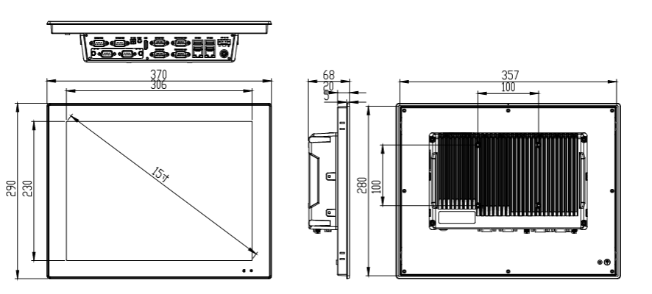

**11.Dimensions:**